MongoDB Assignment A

Question=1 Create a new database called student_management.
use Students_Management
Question=2 Create a collection called students in the student_management database.
db. createCollection("Students")
Question=3 Insert at least five student records into the students collection. Each record should have the following fields:
- student_id (integer)
- name (string)
- age (integer)
- department (string)
- courses (array of strings)
- grade (string)
db. Students.insertMany([
{
student_id: 101,
name: "Rahul",
age: 20,
department: "Computer Science",
courses: ["Database Systems","Data Structures"],
grade: "A"
},
{
student_id: 102,
name: "Amit",
age: 22,
department: "Mechanical",
courses: ["Thermodynamics","Machine Design"],
grade: "B"
},
{
student_id: 103,
name: "Sara",
age: 23,
department: "Computer Science",
courses: ["Database Systems","Operating Systems"],
grade: "A"
},
{
student_id: 104,
name: "Neha",
age: 21,
department: "Electronics",
courses: ["Digital Electronics","Microprocessors"],
grade: "C"
},
{
student_id: 105,
name: "Ali",
age: 24,
department: "Computer Science",
courses: ["Networking","Database Systems"],
grade: "D"
}
])
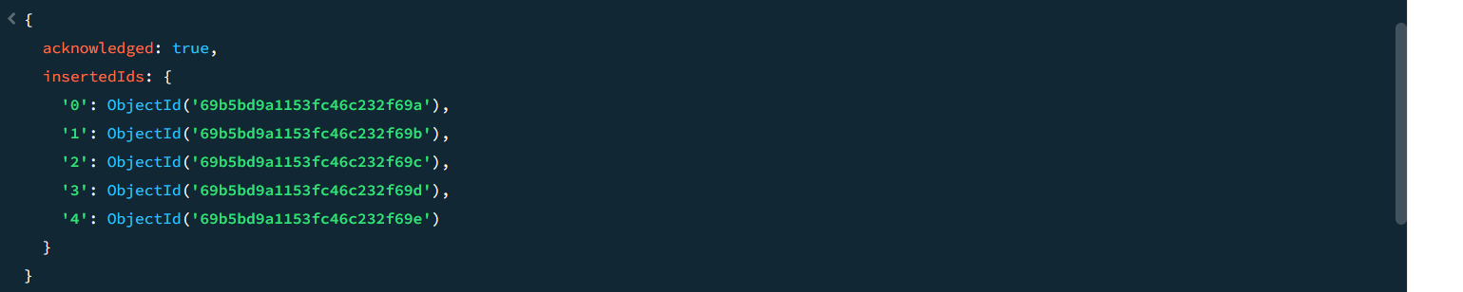
db. Students.find()
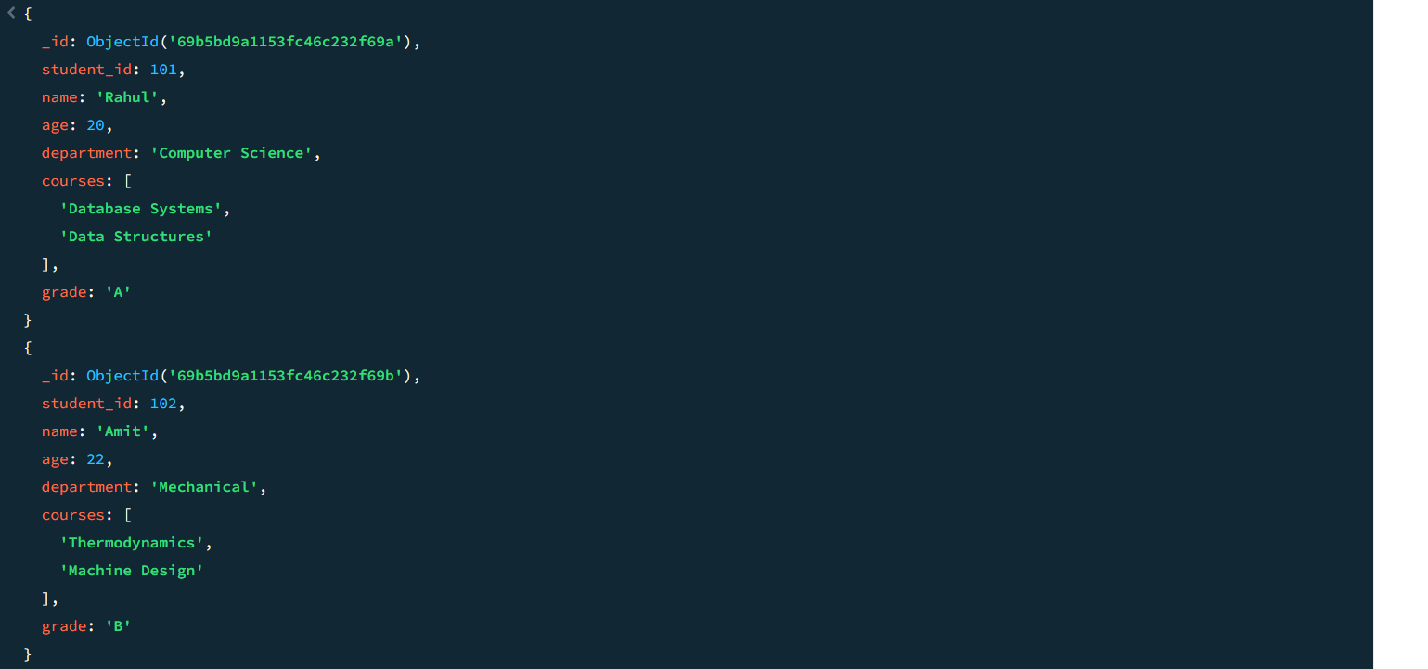
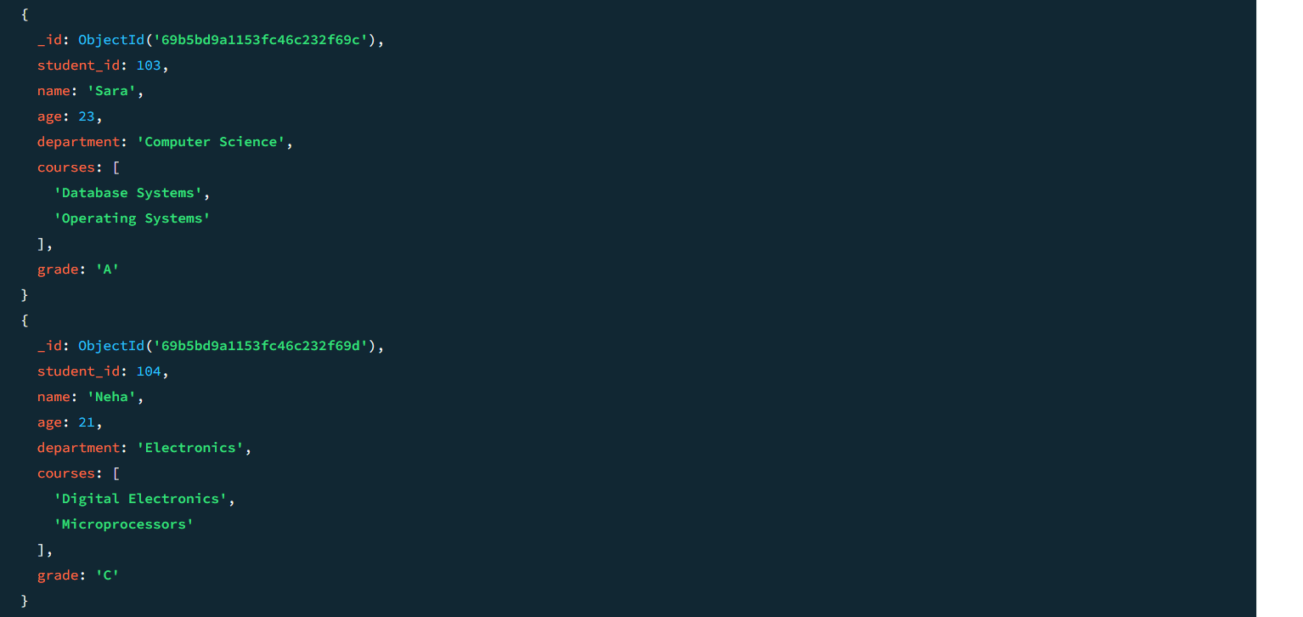
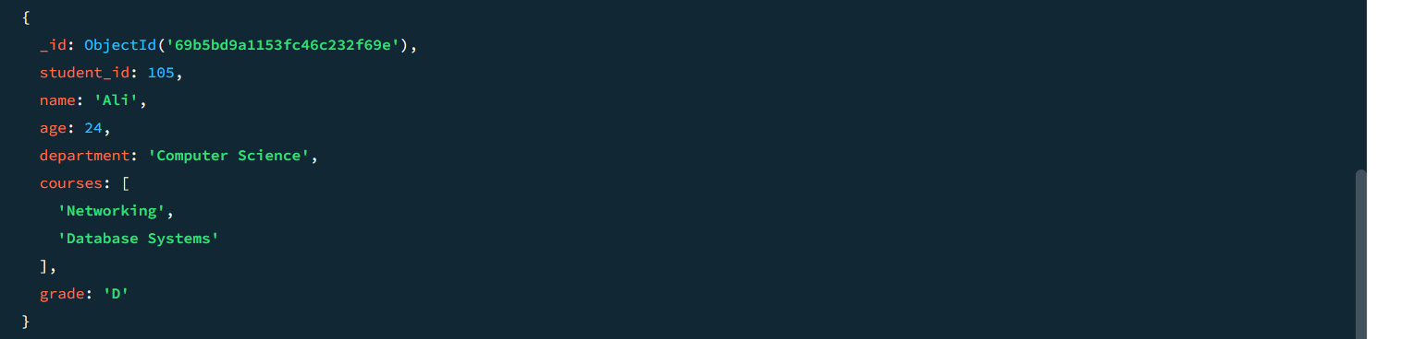
Question=4 Query the Collection:
Write queries to perform the following tasks:
Retrieve all students who are in the "Computer Science" department.
- db. Students.find({department:"Computer Science"})
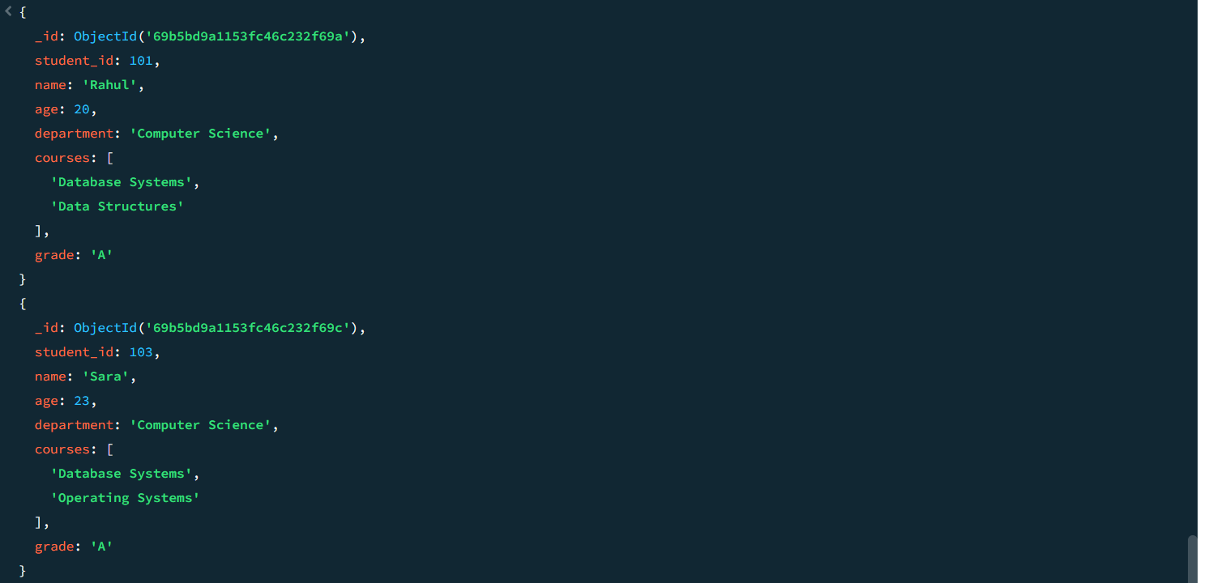
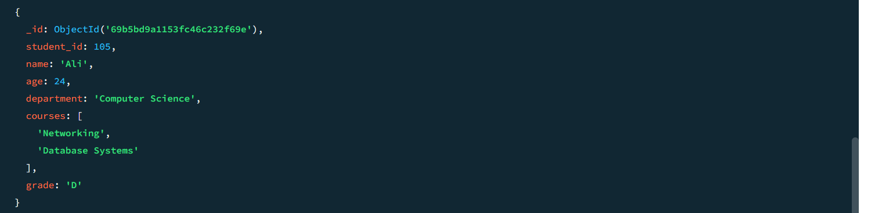
Retrieve students who have an age greater than 21.
- db. Students.find({age: {$gt:21}})
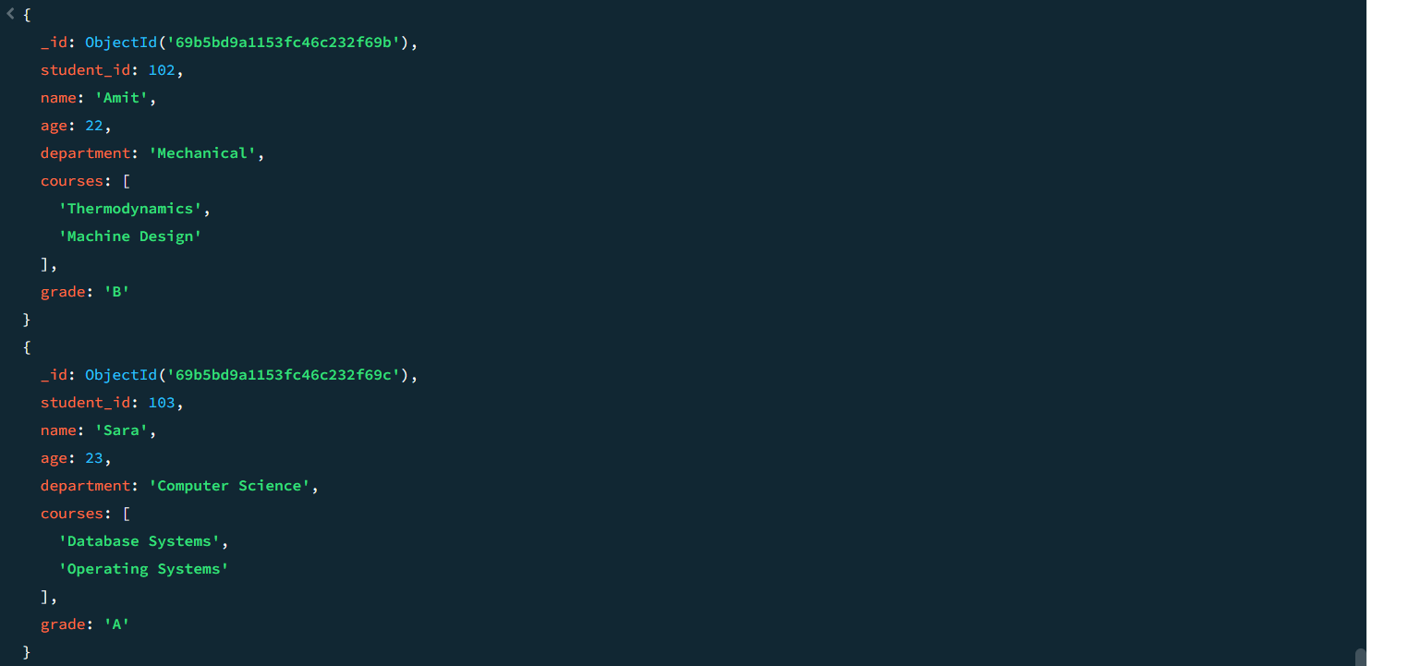
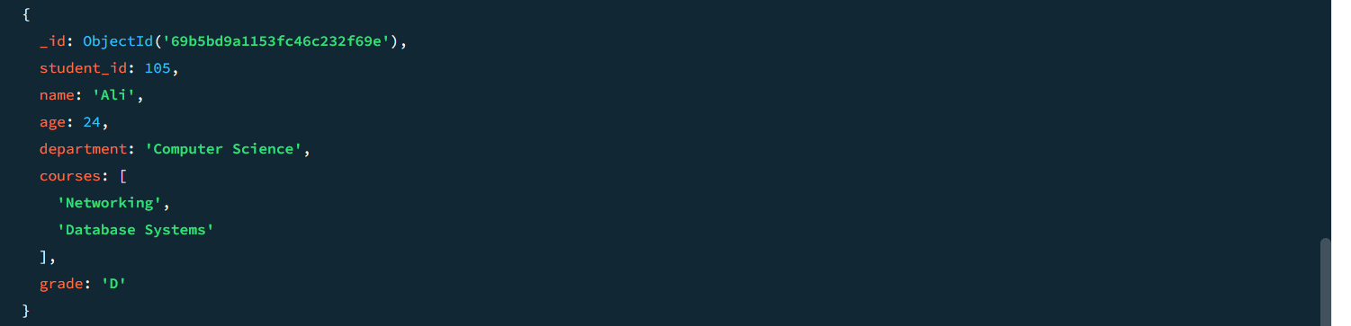
Retrieve students who are taking the "Database Systems" course.
- db. students. find ({courses:"Database Systems"})
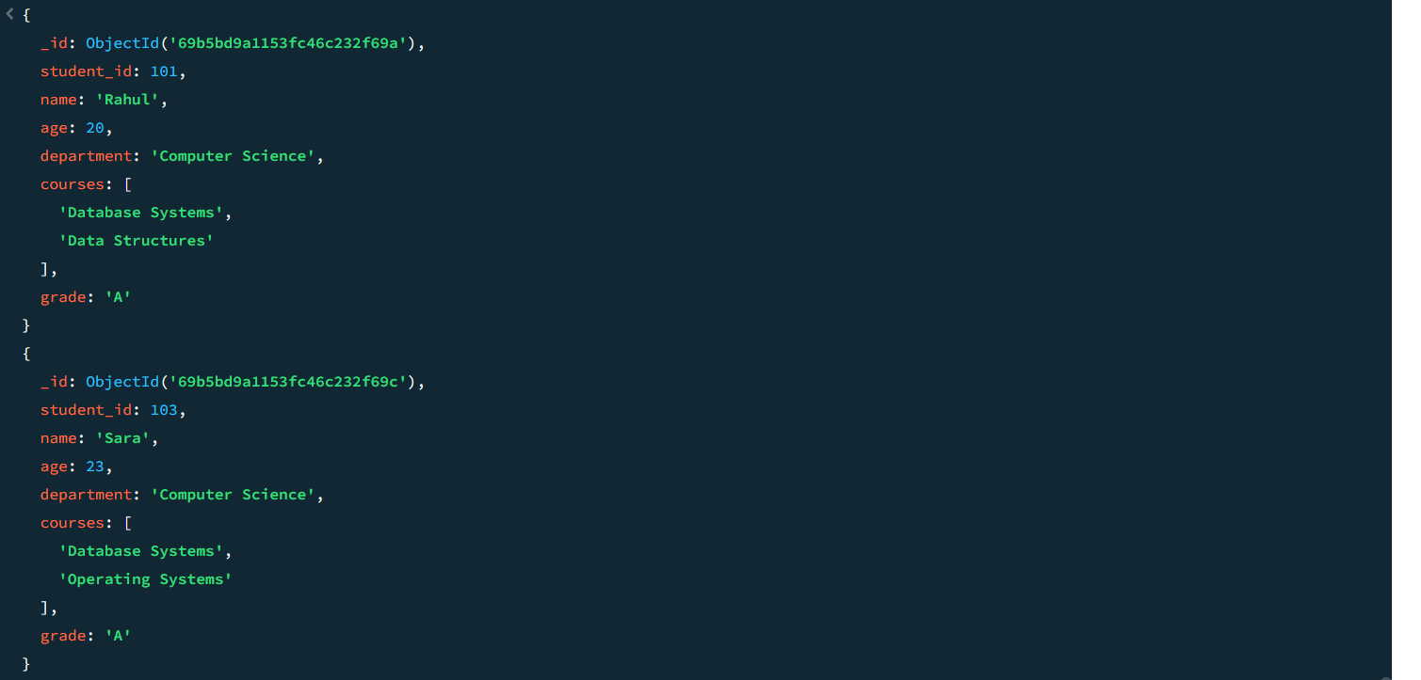
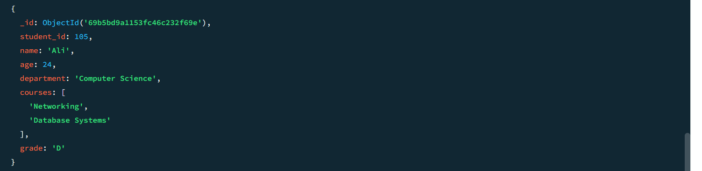
Retrieve students with a grade of "A".
- db. Students.find({grade:” A"})
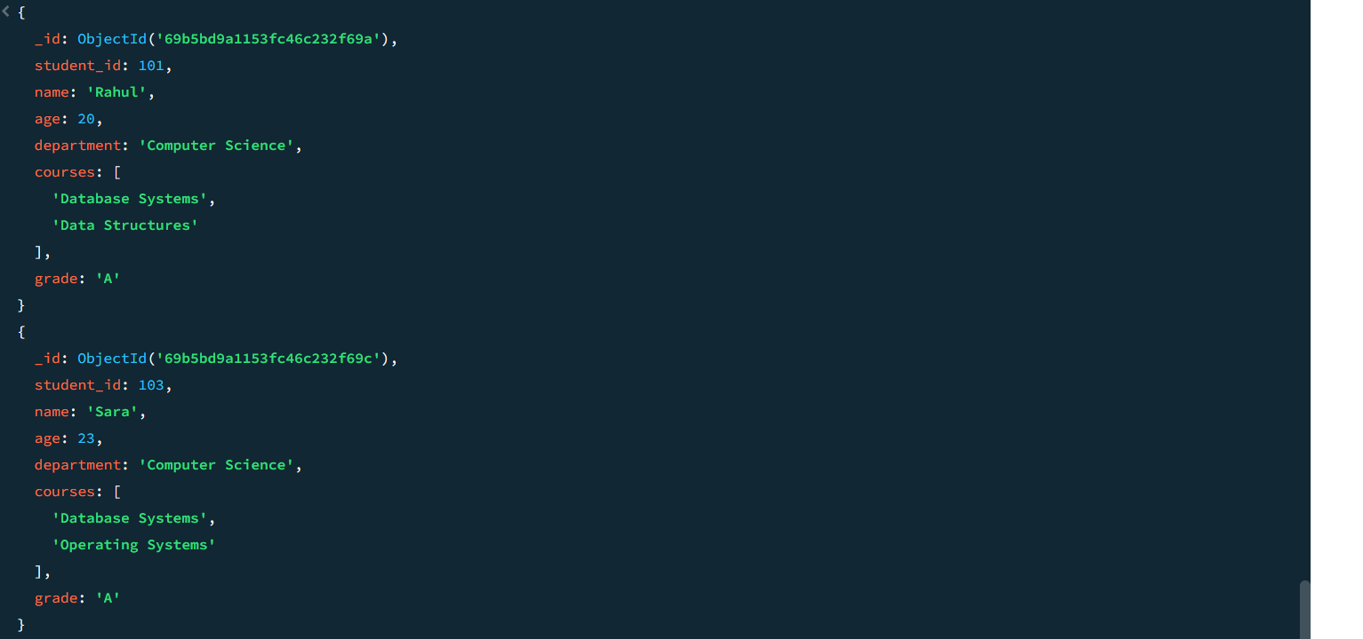
Question=5 Update Documents:
Update the age of a student with student_id 101 to 21.
- db. Students. updateOne({student_id:101},{$set: {age:21}})
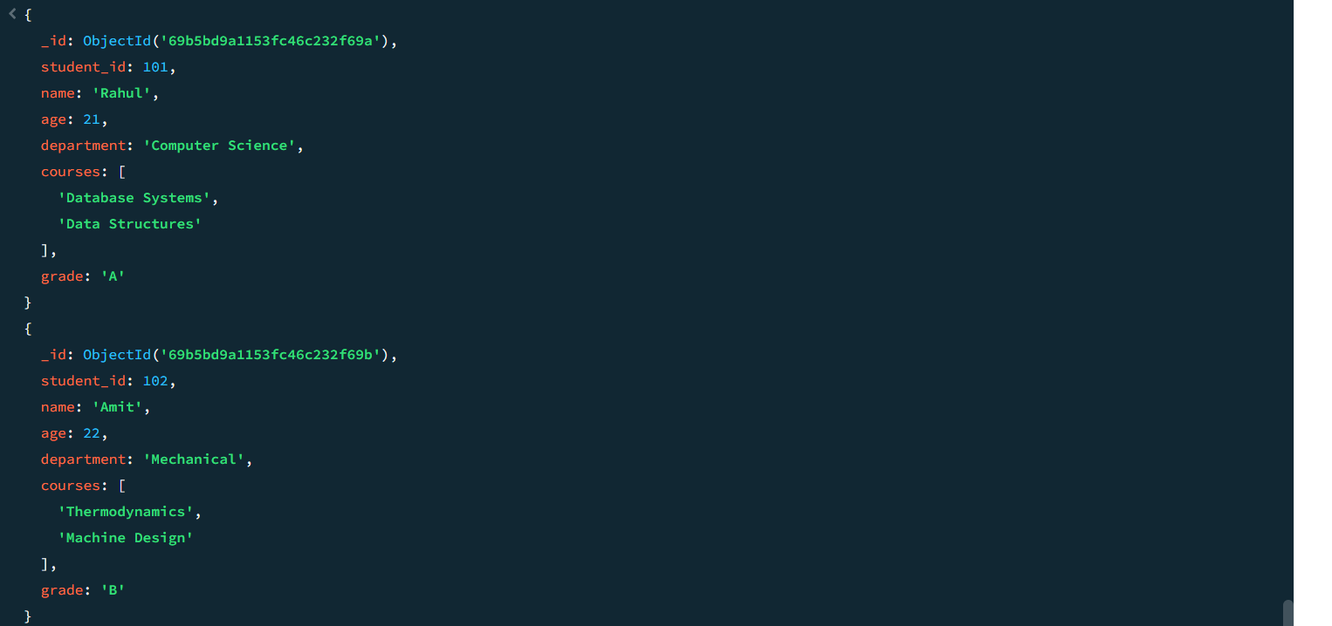
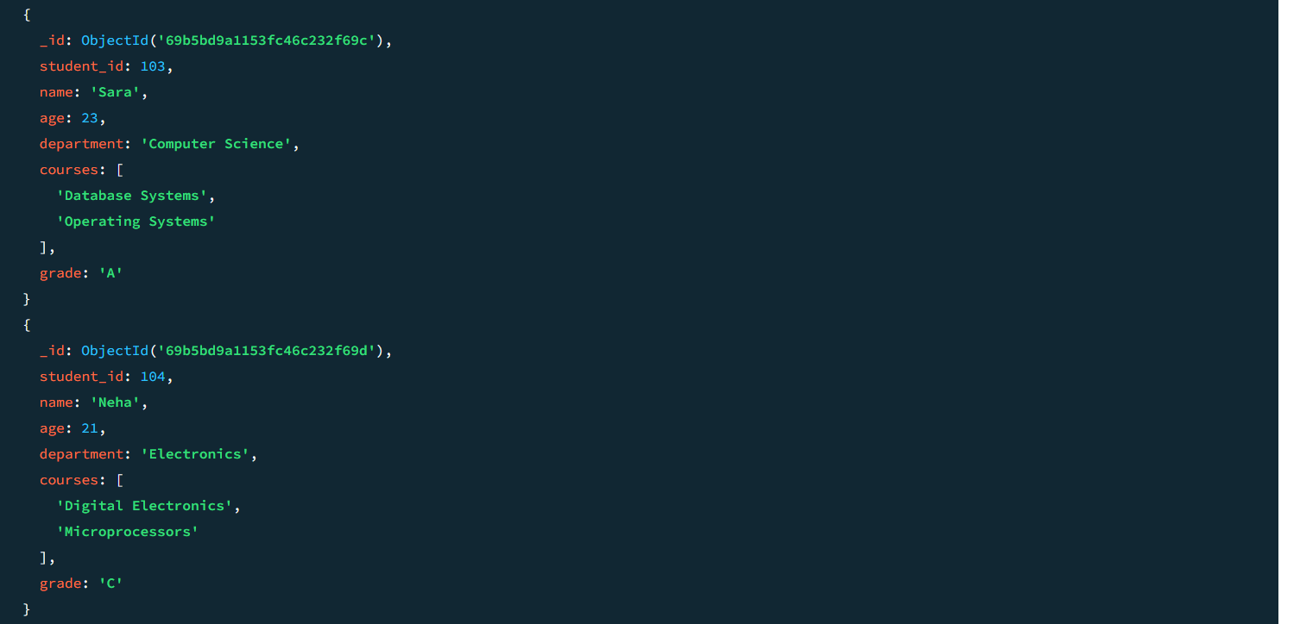
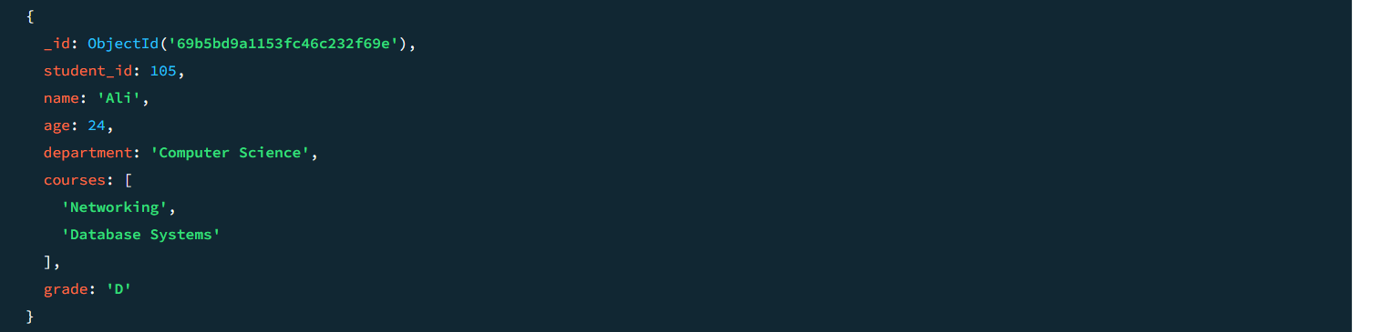
Add a new course, "Machine Learning", to the courses array for students in the "Computer Science" department.

- db.Students.updateMany({department:"ComputerScience"},{$push:{courses:"Machine Learning"}})

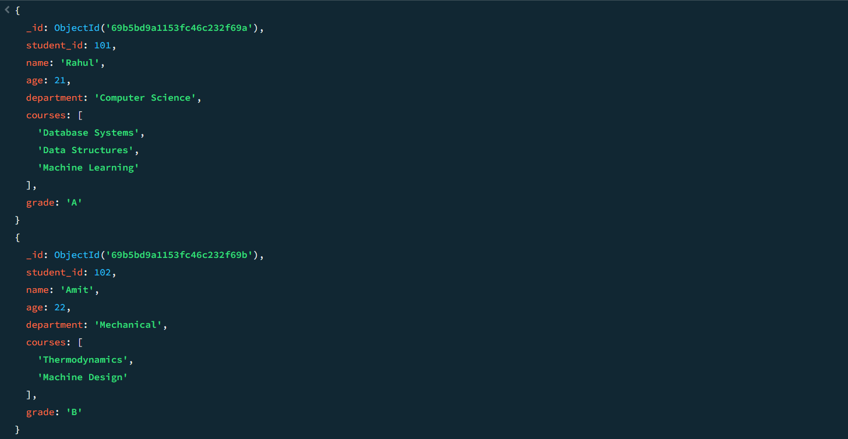
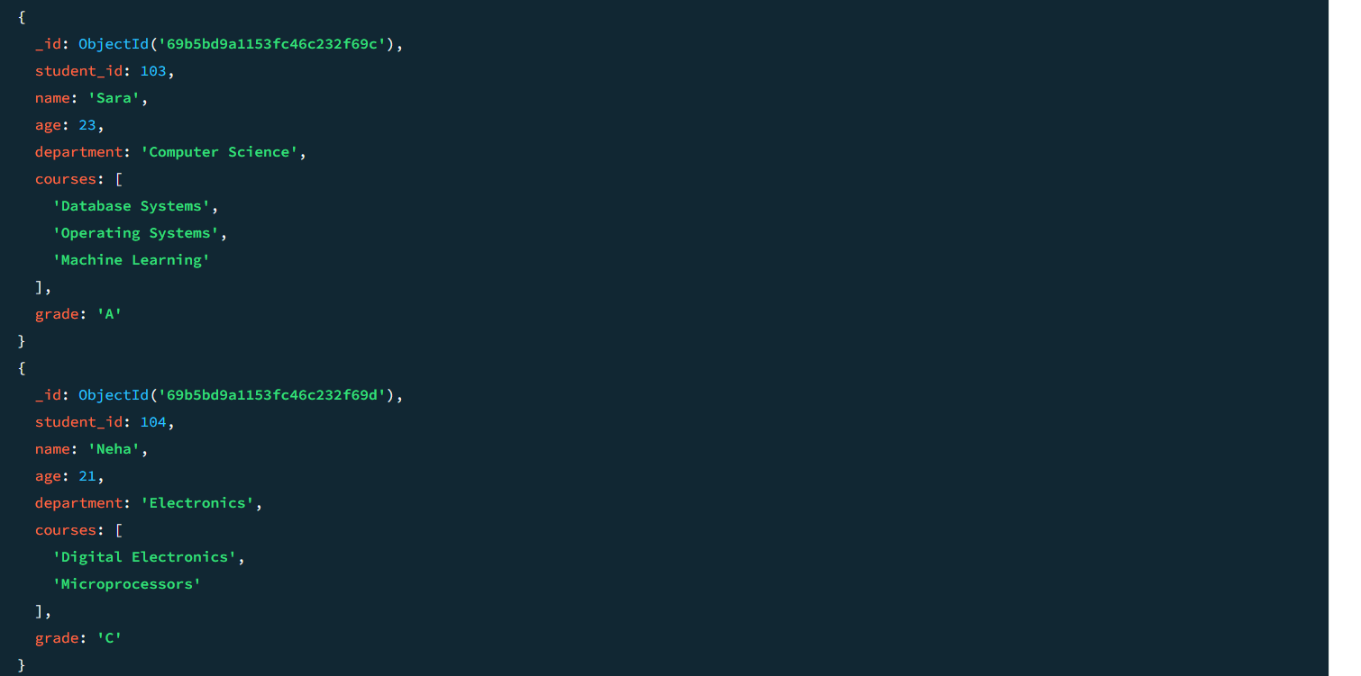

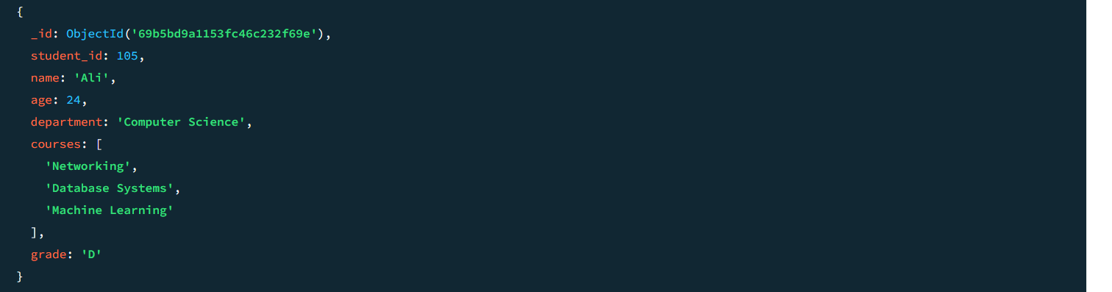

Question=6 Delete Documents:

Delete a student record with student_id 105.

- db.Students.deleteOne({student_id:105})

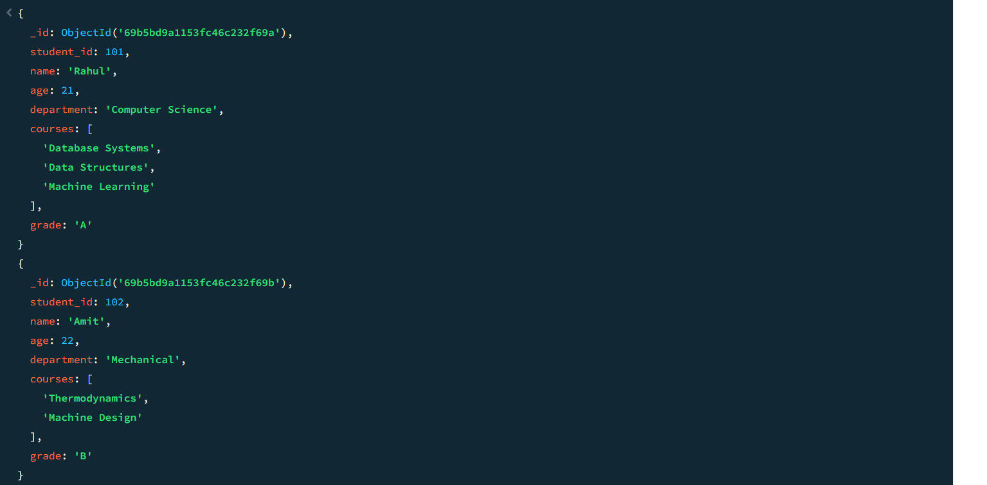

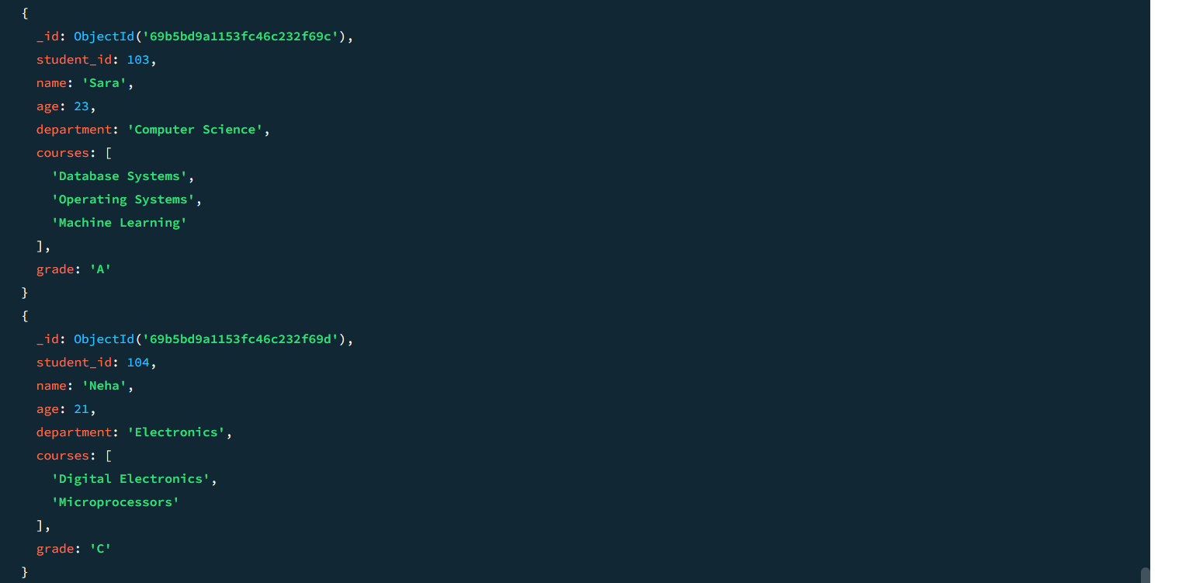

Delete all students who have a grade lower than "C".
- db.students.deleteMany({grade:{$lt:"C"}})
